EXPT NO:2 | LOAD AND VISUALIZE A DATASET USING TABLEAU and PowerBI
DATE: 10.07.2026

PRE-LAB QUESTIONS (PROVIDE BRIEF ANSWERS TO THE FOLLOWING QUESTIONS)

1. Why is Tableau a preferred tool for data visualization?
Tableau is preferred because it makes data visualization simple and interactive. Its drag-and-drop interface allows users to create charts and dashboards easily, while its ability to connect to different data sources helps in analyzing large datasets effectively.

- What is the primary use of a line chart in data analysis?
A line chart is mainly used to show trends and changes over time. It helps in understanding how values increase, decrease, or fluctuate across a specific period.

3.When would you use a tree map instead of a bar chart?
A tree map is useful when comparing many categories and their proportions within a whole. It is preferred over a bar chart when hierarchical data or space-efficient comparison is needed.

- What is the significance of filters in Tableau visualizations?
Filters help users focus on specific data by removing unnecessary information from the view. They make dashboards more interactive and allow better analysis of selected categories or time periods.
- How does Tableau handle geographic data for visualizations?
Tableau automatically recognizes geographic data such as countries, states, and cities. It converts this information into map-based visualizations using latitude and longitude coordinates, making location analysis easier.

IN-LAB EXERCISE:
OBJECTIVE:
To load a dataset into Tableau, create a variety of visualizations, and derive insights from the data using different chart types available in Tableau.
PROCEDURE:
Dataset Selection:
Use the Global Superstore Sales Dataset (available on Kaggle or Tableau's sample datasets).
Ensure the dataset includes fields like Order Date, Category, Region, Sales, Profit, and Customer Segment.
Data Loading:
Open Tableau and connect to the dataset.
Review the dataset structure, field data types, and missing values.
Chart Creations (Step-by-Step):
- Bar Chart:
Objective: Compare total sales by region and category.
Plot Region on the x-axis and Sales on the y-axis.
Add Category as a color dimension.
- Line Chart:
Objective: Visualize sales trends over time.
Place Order Date on the x-axis and Sales on the y-axis.
Set granularity to Month and color by Category.
- Pie Chart:
Objective: Show sales distribution by product category. Assign Category as the dimension and Sales as the measure.
- Scatter Plot:
Objective: Examine the relationship between profit and sales.
Plot Profit on the x-axis and Sales on the y-axis.
Use Sub-Category as the color dimension.
- Heatmap:
Objective: Compare sales across categories and regions.
Use Region and Category as dimensions. Use Sales as the measure and apply color coding.
- Geographical Map:
Objective: Visualize total sales by country.
Set Country as the geographical field. Use Sales to define size and color gradients.
- Tree Map:
Objective: Display sales distribution by category and sub-category.
Use Category and Sub-Category as dimensions, and Sales as the measure.
Customization and Interactivity:
Add filters to explore data subsets interactively (e.g., by year, region, or category).
Include annotations, labels, and formatting for clarity.
Dashboard Creation:
Combine all charts into a single dashboard to present a cohesive story.
Add interactive filters and tooltips for dynamic exploration.
Experiment Dataset:
Global Superstore Sales Dataset
Source: https://www.kaggle.com/datasets/apoorvaappz/global-super-store-dataset
Fields Used:
Order Date
Region
Category
Sub-Category
Sales
Profit
Country

TABLEAU DASHBOARD:

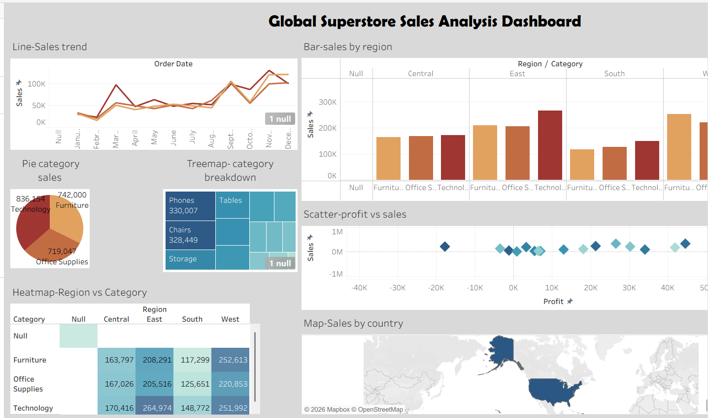

POWER BI DASHBOARD:

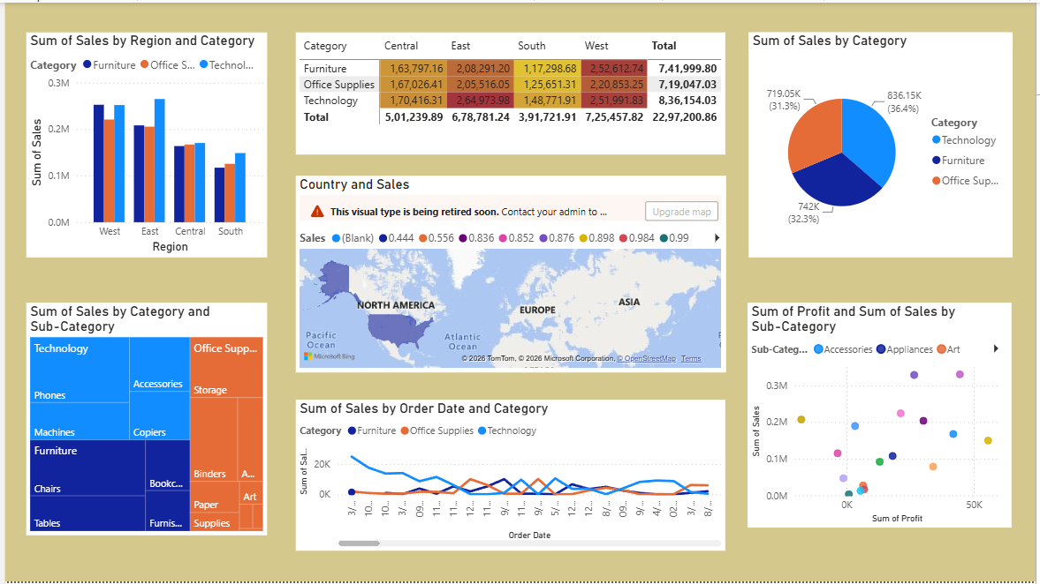

POSTLAB QUESTIONS :

Bar Chart
- What regions had the highest and lowest total sales?
The West region recorded the highest total sales among all the regions analyzed. In contrast, the South region had the lowest total sales, indicating comparatively weaker sales performance during the analyzed period.

- How does the performance of categories vary across regions?
The performance of categories varied across different regions. Technology generally showed strong sales performance in most regions, while Furniture and Office Supplies showed moderate variations depending on the region. This indicates that customer demand differs geographically.

Line Chart
- Identify the month with peak sales.
November was identified as the month with peak sales. This suggests that sales increased significantly during this period, possibly due to seasonal demand or promotional activities.

- Which category shows consistent growth in sales over time?
The Technology category showed the most consistent growth in sales over time. Its sales trend demonstrated a steady upward movement compared to other categories.

Pie Chart
- Which category contributes the most to overall sales?
The Technology category contributes the largest share to overall sales. This indicates that technology products are the major revenue-generating segment in the dataset.

- Are there any categories with negligible sales contributions?
No category had a completely negligible contribution to sales. However, some categories contributed significantly less when compared to the dominant Technology category.

Scatter Plot

- Is there a noticeable correlation between profit and sales?
Yes, there is a noticeable positive correlation between profit and sales. In general, higher sales tend to generate higher profit, although some products with high sales may still produce low profit margins.

- Which sub-category shows the highest sales but low profit?
The Tables sub-category showed relatively high sales but low profit. This suggests that despite strong sales volume, profitability was limited due to higher costs or lower margins.

Heatmap

- Which region-category combination has the highest sales?
The combination of the West region and the Technology category had the highest sales. This indicates a strong market demand for technology products in the West region.

- Identify any regions with poor sales performance across all categories.
The South region demonstrated comparatively poor sales performance across most categories, indicating lower overall market performance in that region.

Geographical Map

- Which country has the highest total sales?
The United States recorded the highest total sales in the geographical analysis. This highlights its dominant contribution to the overall sales dataset.

- Are there regions with minimal or no sales?
Some regions showed minimal sales contributions, but no major region had zero sales. This indicates that sales activity was present across most geographic areas.

Tree Map
- Which sub-category dominates the sales in each category?
Within Technology, Phones dominated sales. In Furniture, Chairs contributed the highest sales, while Storage was the leading sub-category in Office Supplies.

- Are there any sub-categories with unexpectedly low sales?
Yes, certain sub-categories such as Fasteners showed unexpectedly low sales compared to other sub-categories within the same category.

Dashboard

- What insights can you derive when combining all visualizations?
By combining all visualizations, the dashboard provides a comprehensive view of sales trends, regional performance, category contributions, profitability, and geographic distribution. It helps identify high-performing areas as well as regions or products requiring improvement.

- How do filters enhance the utility of the dashboard?
Filters enhance the dashboard by allowing users to focus on specific regions, categories, time periods, or products. This improves interactivity and enables detailed analysis based on user-selected criteria.

ASSESSMENT

Description |  | Max Marks | Marks Awarded
Pre Lab Exercise |  | 5
In Lab Exercise |  | 10
Post Lab Exercise |  | 5
Viva |  | 10
 | Total | 30
 |  | Faculty Signature

